**Exercise 01**

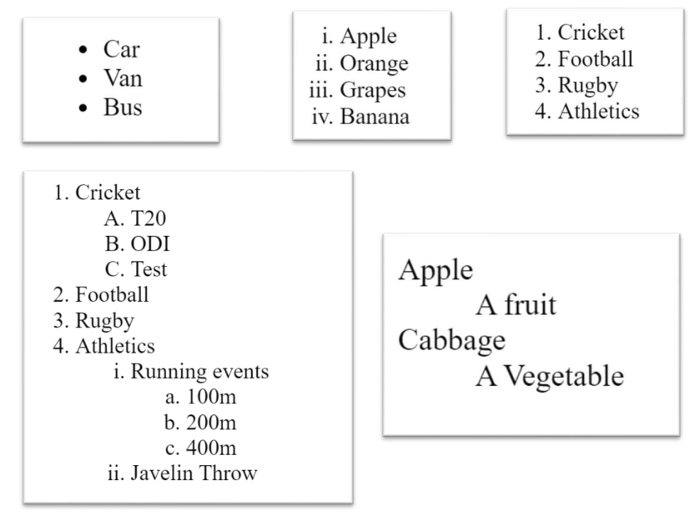Write down the HTML codes required to generate the following outputs.

<html>

<head>

<title> List 1 </title>

</head>

<body>

<ul>

<li> Car </li>

<li> Van </li>

<li> Bus </li>

</ul>

<hr>

<ol type="i">

<li> Apple </li>

<li> Orange </li>

<li> Grapes </li>

<li> Banana </li>

</ol>

<hr>

<ol>

<li> Cricket </li>

<li> Football </li>

<li> Rugby </li>

<li> Athletics </li>

</ol>

</body>

</html>

**Exercise 02**

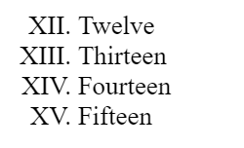

<html>

<head>

<title> List 2 </title>

</head>

<body>

<dl>

<dt> Apple </dt>

<dd> A fruit </dd>

<dt> Cabbage </dt>

<dd> A Vegetable </dd>

</dl>

<hr>

<ol type="I" start="12">

<li> Twelve </li>

<li> Thirteen </li>

<li> Fourteen </li>

<li> Fifteen </li>

</ol>

</body>

</html>

**Exercise 03**

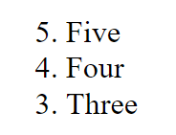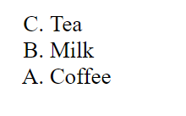

<html>

<head>

<title> List 3 </title>

</head>

<body>

<ol type="A" start="3" reversed>

<li> Tea </li>

<li> Milk </li>

<li> Coffee </li>

</ol>

<hr>

<ol type="1" start="5" reversed>

<li> Five </li>

<li> Four </li>

<li> Three </li>

</ol>

</body>

</html>

**Exercise 04**

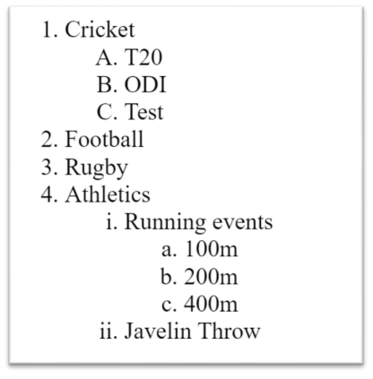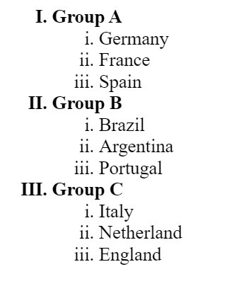

<html>

<head>

<title> List 4 </title>

</head>

<body>

<ol type="I">

<li> Group A </li>

<ol type="i">

<li> Germany </li>

<li> France </li>

<li> Spain </li>

</ol>

<li> Group B </li>

<ol type="i">

<li> Brazil </li>

<li> Argentina </li>

<li> Portugal </li>

</ol>

<li> Group C </li>

<ol type="i">

<li> Italy </li>

<li> Netherland </li>

<li> England </li>

</ol>

<br>

<hr>

<br>

<ol>

<li> Cricket </li>

<ol type="A">

<li> T20 </li>

<li> ODI </li>

<li> Test </li>

</ol>

<li> Football </li>

<li> Rugby </li>

<li> Athletics </li>

<ol type="i">

<li> Running events </li>

<ol type="a">

<li> 100m </li>

<li> 200m </li>

<li> 400m </li>

</ol>

<li> Javelin Throw </li>

</ol>

</ol>

</body>

</html>